“Baggage Check”

**Brackeys Game Jam, Feb. 2022 | Theme: It is Not Real**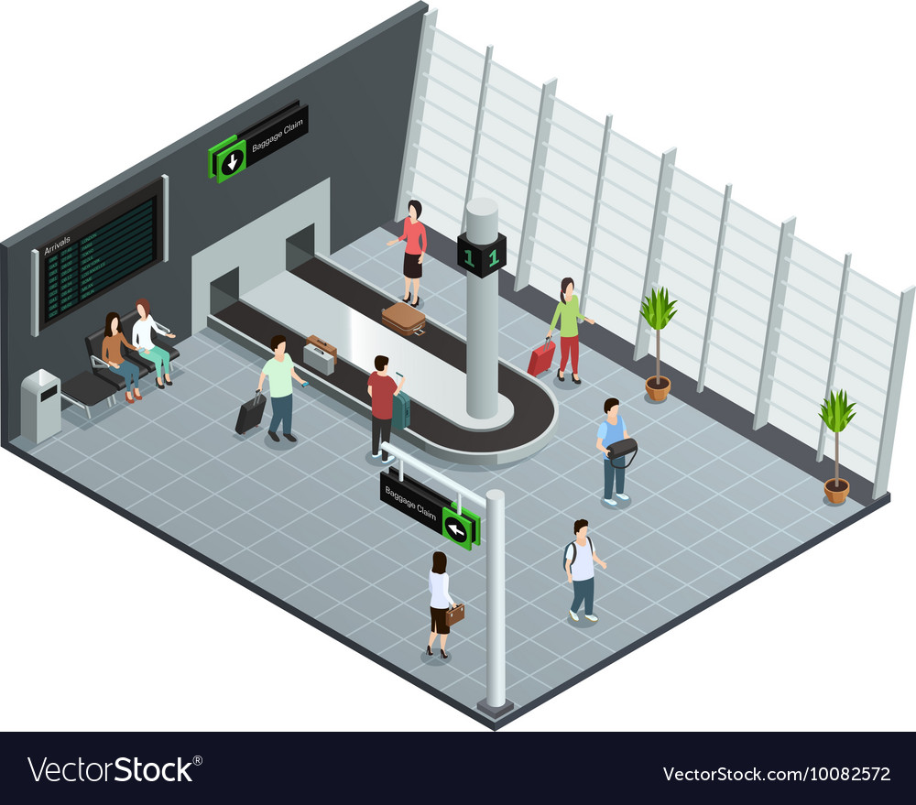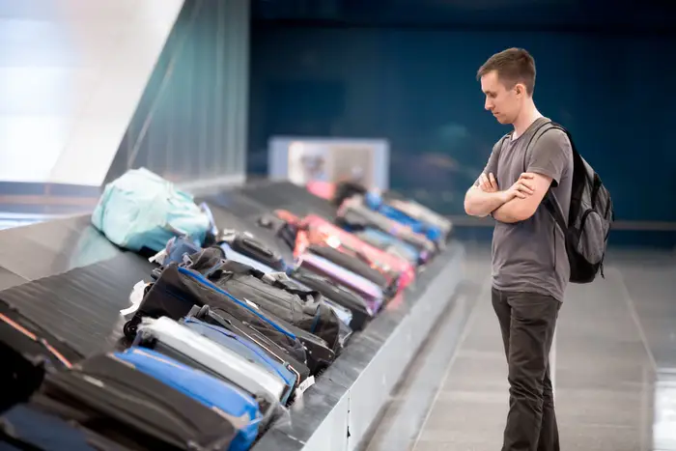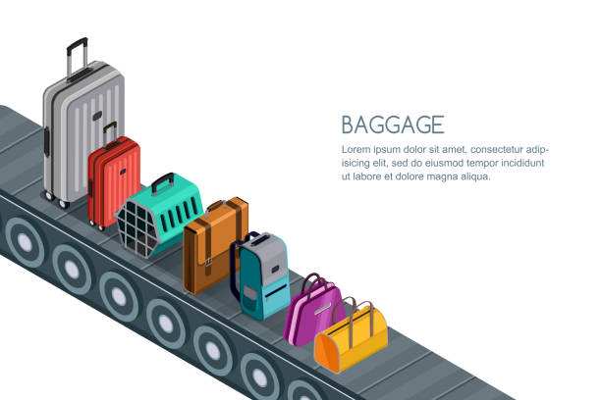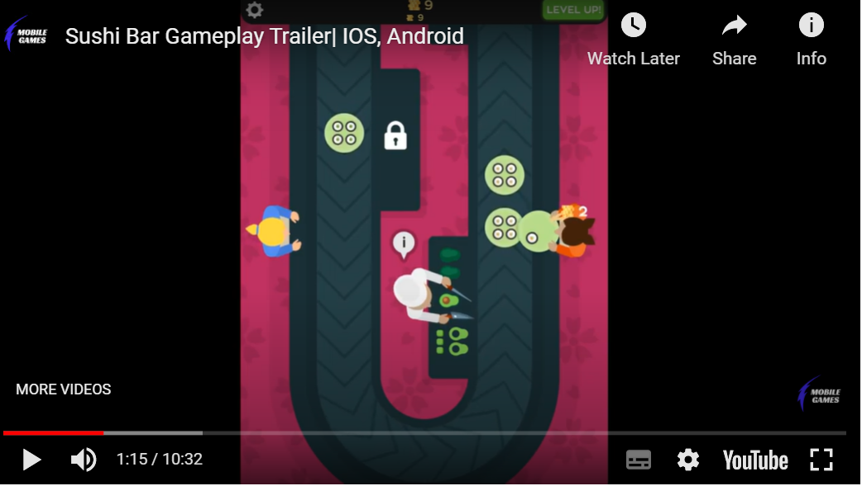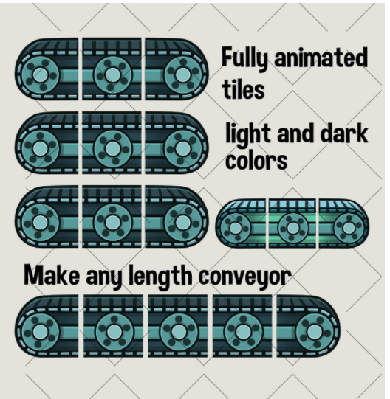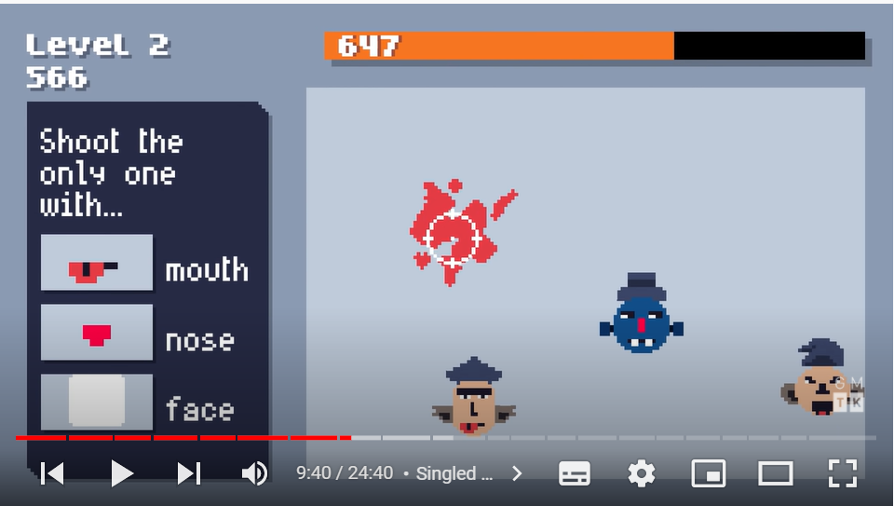

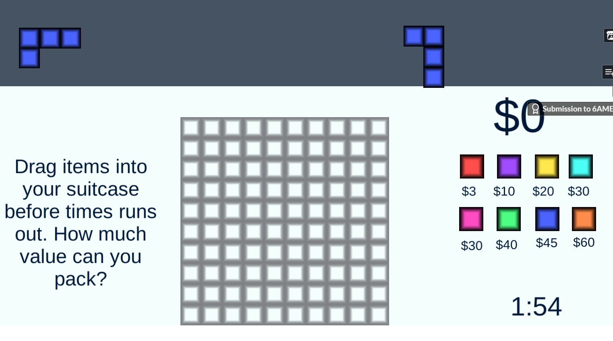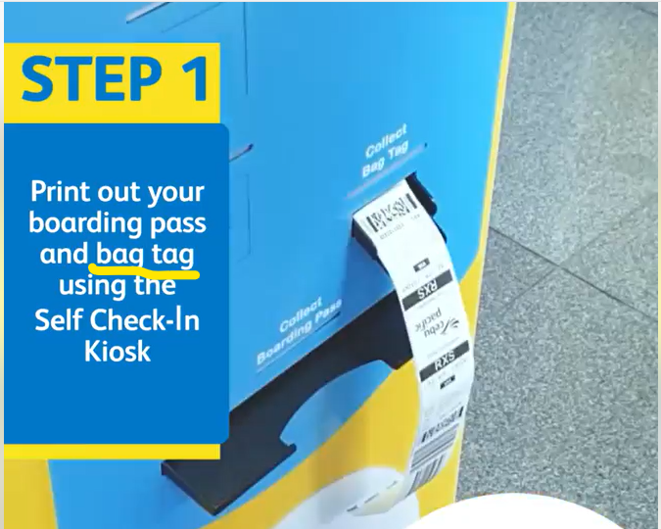

## 

## Game Identity / Mantra:

Conveyor belt-based “find the fake” arcade game about sorting bags as they travel along a baggage carousel at an airport.

## Design Pillars:

* Fun
* Game Loop
* Rewarding

## Genre/Story/Mechanics Summary:

A conveyor belt is stationed in the middle of the screen. Bags enter from an entry point constantly, passing through until reaching a baggage carousel where passengers claim bags.

There’s a guide at the beginning of each day, telling you to look out for bags with certain features that you must get rid of immediately.

## Features:

List the cool features or unique elements that you want to include in your game.

## Interface:

List the player input method, the controls, and how the player interacts with your game.

## Art Style:

Include references to lots of images and games that have a similar aesthetic to what you're trying to achieve.

## Music/Sound:

Include links to music and sound design similar to What you're trying to achieve. You can also list the emotional responses that the sound should invoke in the player.

## Development Roadmap / Launch Criteria:

**Platform:** Steam/Google Play/iOS/Web. **Audience:** Age/gender/interests.

| **Milestone 1:** Mechanics complete - 0/0/00  **Milestone 2:** Boss fights complete - 0/0/00  **Milestone 3:** Levels complete - 0/0/00 | **Milestone 4:** Polish complete - 0/0/00  ---------------------------  **Launch Day:** 0/0/00 |
| --- | --- |